***No. 1 PLASMA POWER SUPPLY HYPERTHERM***

Model *XPR 300 CORE / VWI / OPTIMIX automatic gas console*

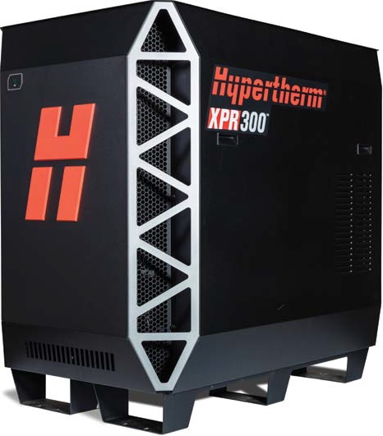

The most significant advance in mechanized plasma cutting technology redefines what plasma can do.

***Industry leading cut quality – X-Definition***

The XPR advances Hy-definition cut quality by blending new technology with refined processes for next generation,

X –Definition cutting on mild steel, stainless steel and aluminum.

* Consistent ISO range 2 results on thin mild steel and extended range 3 quality thicker mild steel and stainless steel
* Superior results on aluminum using Vented Water Injection (VWI)

***Optimized productivity and reduced operating costs***

* Operating costs reduced by over 50%
* Up to 15% higher cut speeds on thicker materials
* Consumables life increases of over 40%
* 20% thicker piercing on stainless steel and 30% ticker on mild steel

***Engineered system optimization and ease of use***

* ******Increases consumable life 3 times that of competitors’ systems by eliminating the impact of ramp down errors
* Reduce the impact of catastrophic electrode blow outs which can damage the torch at high current levels
* Automatic system monitoring and specific troubleshooting codes for improved maintenance and service prompts
* EasyConnect torch lead and one hand torch-to-receptacle connecton for fast and easy change-outs
* QuckLock electrode for easy consumable replacement
* WiFi in the power supply can connect to mobile devices and LAN for multiple system monitoring and service

***Cut thicknesses***

|  |  |
| --- | --- |
| MildSteel | **mm** |
| Pierce capacity (argon-assist) | 50 |
| (Standard O2) | 45 |
| Severance | 80 |
| Stainless steel |  |
| Pierce capacity | 38 |
| Severance | 75 |
| Aluminum |  |
| Pierce capacity | 38 |
| Severance | 50 |

***Number of 20-seconds starts with 5% ramp-down errors***

***Process control and delivery***

Three gas connect console options offer unmatched mild steel cut quality with each console delivering successively enhanced cutting capabilities on stainless steel and aluminum. All consoles can be fully controlled through the CNC for high productivity and ease of use. .



***Specifications***

|  |  |
| --- | --- |
| Maximum open-circuit voltage | 360 VCC |
| Maximum output current | 300 A |
| Maximum output power | 66,5 kW |
| Output voltage | 50-222 VCC |
| 100% duty arc voltage | 222 V |
| Duty cycle rating | 100% a 66,5 kW, 40 °C |
| Operational ambient temperature range | -10 °C – 40 °C |
| Power factor | 0,98 @ 66,5 kW |
| Cooling | Forced air (class F) |
| Insulation | Class H |
| EMC emissions classification (CE models only) | Class A |
| Lift points | Top lift eye |
| Bottom lift truck slots | Lift eye rating 680 kg |

|  |  |  |  |  |
| --- | --- | --- | --- | --- |
| Consolle | Cutting gases | Current (A) | Thickness (mm) | Approximate cutting speed (mm/min) |
| Mild steel | | | | |
| Core, VWI and Optimix | O2 Plasma O2 Shield | 30 | 0,5 | 5348 |
| 3 | 1153 |
| 5 | 726 |
| O2 Plasma Air Shield | 50 | 3 | 3820 |
| 5 | 2322 |
| 8 | 1369 |
| O2 Plasma Air Shield | 80 | 3 | 5582 |
| 6 | 3048 |
| 12 | 1405 |
| O2 Plasma Air Shield | 130 | 3 | 6502 |
| 10 | 2680 |
| 38 | 256 |
| O2 Plasma Air Shield | 170 | 6 | 5080 |
| 12 | 3061 |
| 25 | 1175 |
| 60 | 152 |
| O2 Plasma O2 Shield | 300 | 12 | 3940 |
| 25 | 1950 |
| 50 | 560 |
| 80 | 165 |
| Stainless Steel | | | | |
| Core, VWI and Optimix | N2  Plasma N2 Shield | 40 | 0,8 | 6100 |
| 3 | 2683 |
| 6 | 918 |
| VWI and Optimix | F5 Plasma N2 Shield | 80 | 3 | 4248 |
| 6 | 1916 |
| 12 | 864 |
| Optimix | H2 -Ar- N2 Plasma  N2 Shield | 170 | 10 | 1975 |
| 12 | 1735 |
| 38 | 256 |
| H2 -Ar- N2 Plasma  N2 Shield | 300 | 12 | 2038 |
| 25 | 1040 |
| 50 | 387 |
| 75 | 182 |
| VWI and Optimix | N2 Plasma  H2O Shield | 300 | 12 | 2159 |
| 25 | 1302 |
| 50 | 403 |
| Aluminum | | | | |
| Core, VWI and Optimix | Air PlasmaAir Shield | 40 | 1,5 | 4799 |
| 3 | 2596 |
| 6 | 911 |
| VWI and Optimix | N2  Plasma H2OShield | 80 | 3 | 3820 |
| 6 | 2203 |
| 10 | 956 |
| N2  Plasma H2OShield | 130 | 6 | 2413 |
| 10 | 1702 |
| 20 | 870 |
| N2  Plasma H2OShield | 300 | 12 | 2286 |
| 25 | 1302 |
| 50 | 524 |
| Optimix | H2-Ar- N2 Plasma  N2 Shield | 300 | 12 | 3810 |
| 25 | 2856 |
| 50 | 324 |

**Note:**

* Characteristics and type of material may affect burr-free performance.